**AIRLINE RESERVATION SYSTEM UML DIAGRAMS**

**G.VISHNU VARDHAN**

**(192011079)**

**1.USE CASE DIAGRAM**

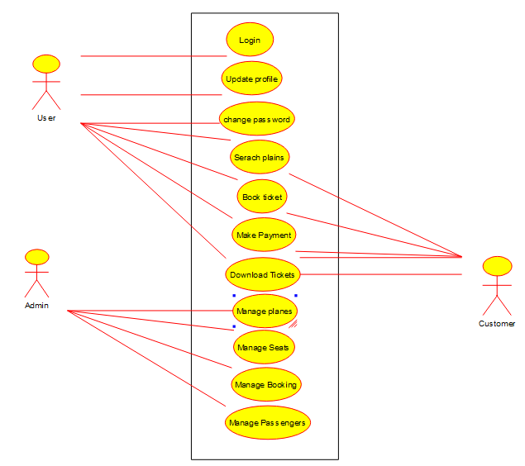

**2.SEQUENCE DIAGRAM**

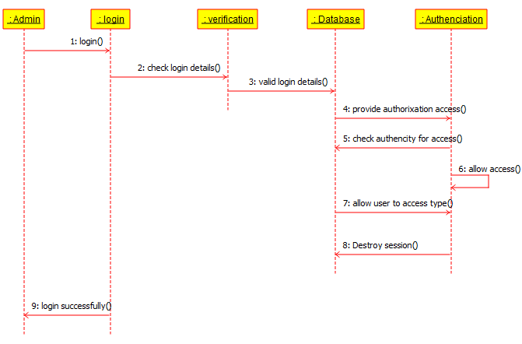

**3.CLASS DIAGRAM**

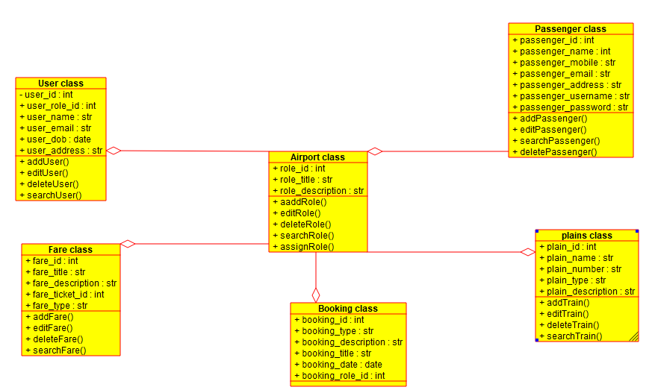

**4.STATE DIAGRAM**

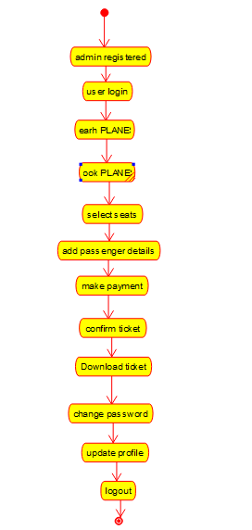

**5.ACTIVITY DIAGRAM**

